CipherLab 8200 User Guide rev. 20160614

PREREQUISITE
You must have a computer (laptop or PC) with Internet access on which to install the communication software and attach the cradle. This will be used to send orders or pick up a new version of software for the device (when available).

GETTING STARTED

- Unpack the 3 boxes you received with your 8200 CipherLab device, your charging cradle, and your pistol grip.
- Log in to the Retailer downloads site at www.dcs-ace.com/retail.asp and download the CipherLab 8200 User Guide.

SETTING UP THE 8200 DEVICE and the CHARGING AND COMMUNICATION CRADLE
- Your 8200 device should arrive fully charged.
- Review the 8200 Mobile Computer Quick Start Guide + 8200 Cradles – Quick Start Guide. The cable in the device box attaches to the cradle (do not attach to the device).
  - The power source plugs into a power outlet.
  - The USB connection plugs into your PC (do not connect to the PC yet).
- There is no microSD Card for the device. The device comes with 4MB of memory and should be enough for your needs. If additional memory is needed an SD card (an additional 4MB or 8MB) can be purchased.
- There is no Product CD. All the information you need is in this User Guide.
- To attach the pistol grip to the device
  - Remove the battery cover of the device. There is a lock and unlock switch at the bottom of the battery cover. Be sure this is pushed to the right (towards the un-lock symbol) to unlock the back plate.
  - Attach the pistol grip (it’s like replacing the battery cover) and push the lock switch on the back of the pistol grip to the left to lock it on the device.
- The device sits in the cradle (with the pistol grip) for charging and sending your orders.

INSTALLING THE COMMUNICATION SOFTWARE ON YOUR PC
- The communication software can be setup on any PC with a Windows Operation System. The Wizards will guide you through multiple installations (applications, drivers, etc). (Do not connect the USB cable from the Cradle to your PC yet.)
- Log in to the Retailer downloads site at www.dcs-ace.com/retail.asp and download the PC software by double clicking on the link CipherExpress Software. This will automatically start the installation of the communication software on your PC. You can also download the user guide from this site. NOTE: The messages you see at the beginning of the install may vary from the ones below depending on the version of Windows you have or the security software you have installed. For example, if you are prompted to trust the download/software, select OK/Yes.

- Click Open when prompted to open or save the zip file:

- Double click on install.exe
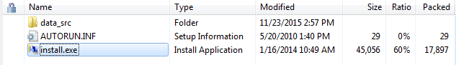

- Click Yes to answer ‘Do you want to install this software?’. Follow the prompts.
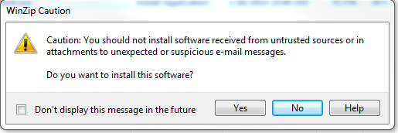

- Click Run when prompted to run the software
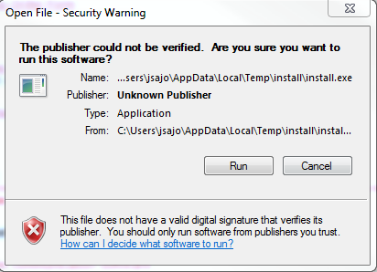

- Accept the terms of the software license agreement:
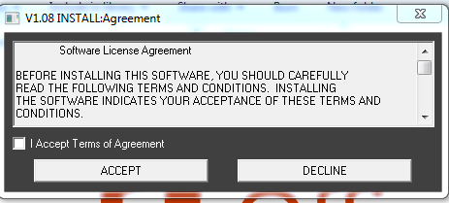

- Select OK to create the c:\cxpress directory
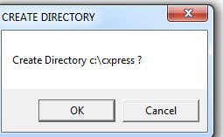
- Click Install Applications. Make sure the ‘Create a shortcut’ is checked so that after the install you will see  on your desktop. This will allow you to quickly start the program when it is time to send an order.
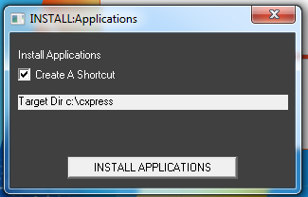

- Click Install Drivers

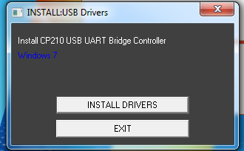

- The warning message below is a reminder to unplug the USB cable from the PC. The installation will not work the cable plugged in.
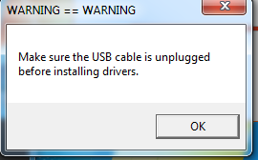

- You will be prompted through the setup Wizard. Click Next when this screen is displayed:
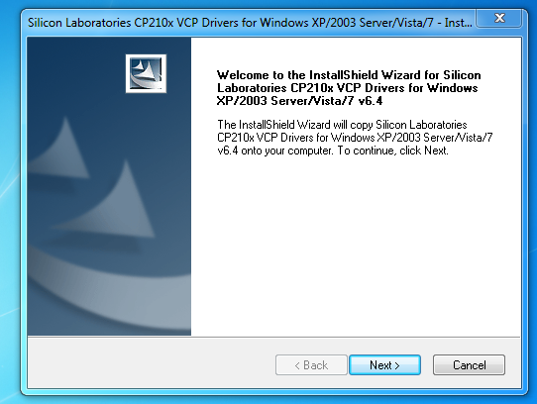

- Accept the terms of the license agreement and select Next
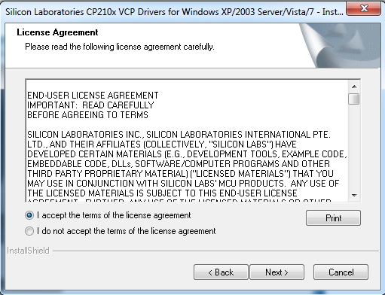

- Leave the default destination location and click Next.
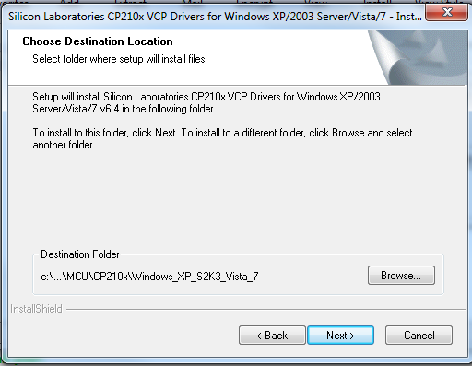

- Click Install.
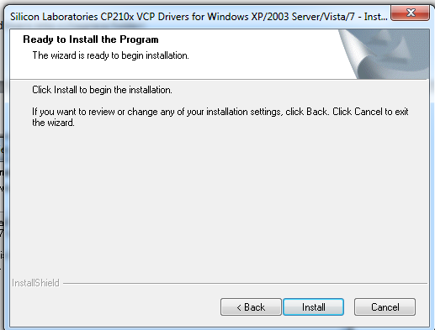

- Click Finish when the InstallShield Wizard completes. Click Finish.
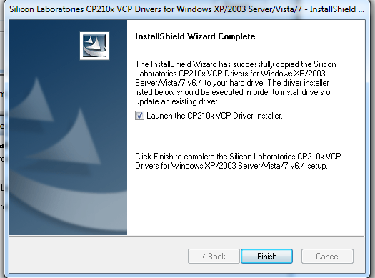

- Click Install.
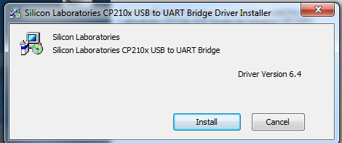

- When the install is completed, you will see the message below. Select OK.
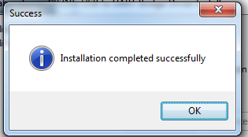

- Click OK
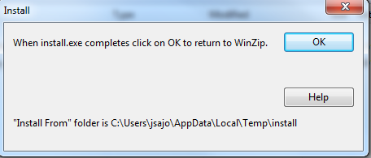

- Exit the WinZip – ace_install.zip folder by clicking the ‘X’ in the upper right corner:

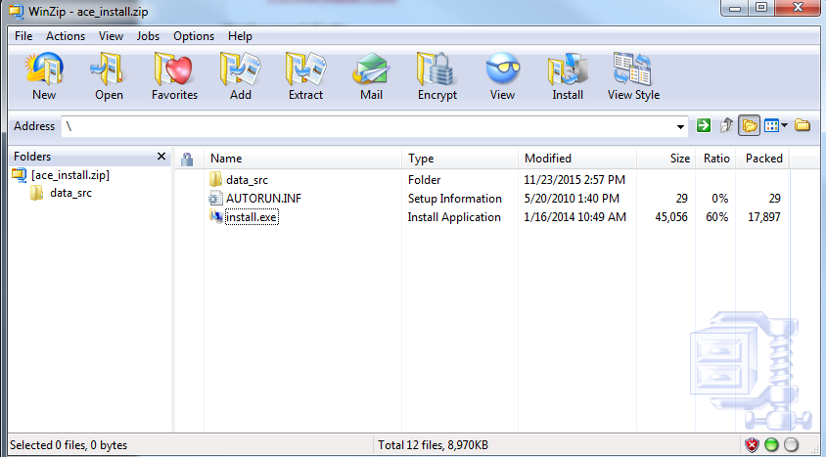

- Exit out of www.dcs-ace.com/retail.asp.

- Plug the cradle USB into the PC. You must do this step now. You will see the message on the PC that the USB drivers have been successfully installed.

- Double click on the shortcut to start the CipherXpress communication software.

- The first time you run the CipherXpress, you will see the following messages.

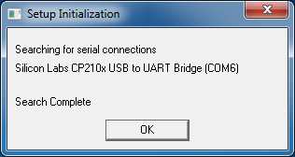
  - Select OK.
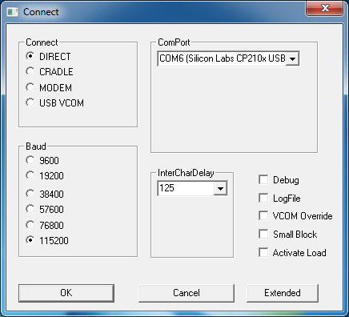
  - Your settings should be the same as above EXCEPT for the ComPort (that will vary depending on your setup). Select OK.

  - When the Cipher Express software is running, it will look like this:
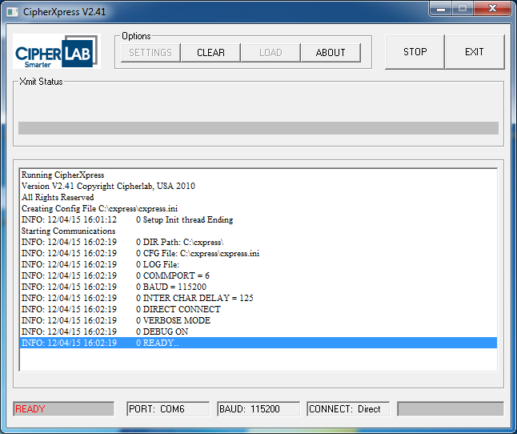

- The first time you transmit an order, you will see the message below. Select Y.
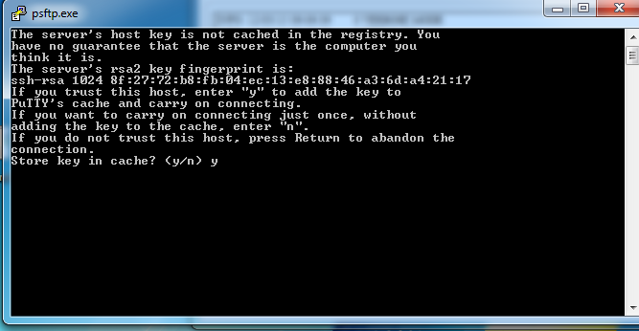

INSTALLING A NEW VERSION OF SOFTWARE

Your device has the latest version of software already installed on it.

A notification will be sent/posted if future versions of software should be installed on your device. To install a new version of software on your device, follow these steps:
- Make sure your device is in the cradle and the CipherExpress software is running on your PC
- From the Main Menu, select - - (dash dash) to invoke the Utility Menu
- Select Option 6 – New Version
- You will see the Message: Press Blue to Start Transmission. Select the Enter (blue) key to start the download of the new software.
- You will see multiple transmission messages. When the Main Menu is displayed on the device, you can remove the device from the cradle.
- The new version number of the software displays under the ‘ORDERING’ heading on the Main Menu.

Now you are ready to turn on your device. The first time you turn on your device, the Main Menu will display. Please review the device settings (see 5. SETUP under MENUs). You may need to adjust the time on the device to your time zone.

GETTING TO KNOW YOUR CIPHERLAB 8200 DEVICE:

CIPHERLAB 8200 DEVICE
SCANNER
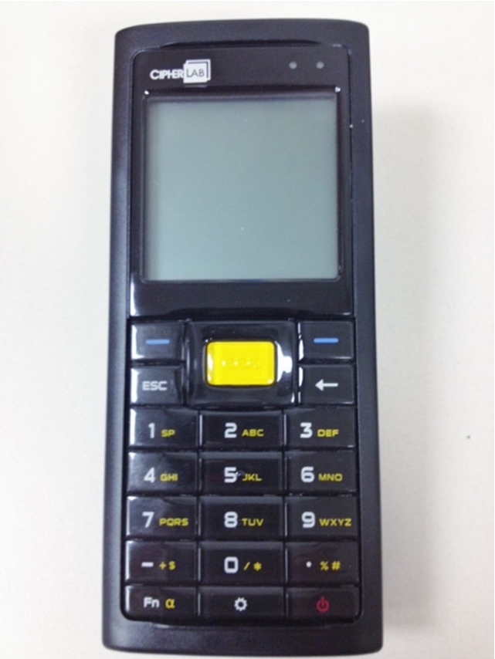
SCAN
KEY
ENTER
KEYS
ESCAPE
KEY
UP/DOWN
BUTTONS
POWER BUTTON
BACK ARROW

NAVIGATION INFORMATION:

Enter | Use either of the 2 blue keys. This is convenient for a right-handed or left handed person. These are used for command execution or input confirmation.
Erase Input | When the cursor is in a data input field, use the back arrow to erase character by character of the contents of the field.
Escape | Use the ESC button to get out of a function.
Move Up/Down | There is a 2 way navigation pad above and below the yellow scan key that is used to move the cursor up, down, left or right. Use these when scrolling up or down on a menu or when scrolling through your order items in review mode.
On/Off | Use the red button in the lower right corner to turn the device on or off.
Scan | To scan a barcode, point the top of the device (the scanner) at a bar code and hit the yellow key.
Fn | This is the Function/Alpha Key. When pressed, you will see the following symbols in the lower left hand corner of the screen:  A This icon appears when you press the [Fn α] key one time, indicating it is set to alphabetic mode for typing upper-case alphabetic letters.  a This icon appears when you press the [Fn α] key two times, indicating it is set to alphabetic mode for typing lower-case alphabetic letter
Backlight, Contrast and Luminosity | [] Toggle ON/OFF the backlight  [] + [Right] Press these keys at the same time to increase the contrast.  [] + [Left] Press these keys at the same time to decrease the contrast.  [] + [Up] Press these keys at the same time to increase the luminosity.  [] + [Down] Press these keys at the same time to decrease the luminosity.  Right, Left, Up and Down refer to the navigation pad around the Yellow scan key.

MENUS / SCREENS

MAIN MENU

 | VALID KEY(S) | REMARKS
ORDERING  VER. 1.xx.xx |  | Displayed for 3 seconds when the unit is turned on. VER. represents the version of the software of the device. This is also displayed as a header on the Main Menu.
ORDERING  VER. 1.xx.xx  - ITEM ENTRY  - REVIEW / EDIT  - SEND PARTITIONS  - ERASE PARTITIONS  - SETUP | 1  2  3  4  5  Enter | This is the Main Menu.  Use any of the numeric keys assigned to a function to highlight a function.  Or, Use the up/down arrow keys to highlight a function.  Use the enter key to initiate a function.

- ITEM ENTRY

STORE 12345  PARTITION 1  PARTITION 2  PARTITION 3  PARTITION 4  PARTITION 5  PARTITION 6  ESC, ..=Chg Store |  | If you select the ITEM ENTRY function and you have no order lines in any of the partitions, you will see this list of available partitions.  The store defaults to the store number entered in system setup.  Each store has 6 partitions. A partition can only contain order lines for a single (1) store.  Select ESC to return to the Main Menu  Enter .. (dot dot) to change the store number
ORDER LIST  S 12345-1  12345-2  .. =NEW, ENTER, ESC |  | If you select the ITEM ENTRY function and you have order lines in any of the partitions, you will see the list of partitions that have order lines.  To continue entering order lines into a partition that is unsent, scroll to one of the partitions listed and select ENTER  A partition that is preceded by an ‘S’ has already been sent and cannot be edited. Sent partitions must be manually erased from the device.  Select .. (dot dot) to open a new partition to enter order lines  - You will see the list of all partitions. If the partition has order lines, it will have a + sign preceding it  - Scroll to a partition without a + preceding it to select an empty partition  - Select Enter to begin item entry  Select ESC to return to the Main Menu.
12345-2  DUPL ITEM ALERT  - DUPL ALERT OFF  - DUPL ALERT ON  12345-2  PO NUMBER  __________ |  | When you select an empty partition to start entering order lines:  - You will be prompted to override DUPL ALERT setting in system setup for the partition selected. Default is ON.  - Scroll the desired setting and select ENTER  - You will be also be prompted to add a PO NUMBER (purchase order number)  - A PO number is not required. Select enter to bypass entering a PO and start item entry  If entered, the PO can be up to 10 characters (alphabetic + numeric); spaces are ok, but special characters are not allowed.  To enter alphabetic characters into the PO, select the Fn key in the lower left corner of the keypad. You will see a capital A in the lower left corner of the screen. In this mode you can  - Enter alphabetic characters from your keyboard  - Enter a space within the PO by selecting the 1 / SP key  To enter numbers in the PO, make sure the Fn key is not enabled. Select the Fn key until there is no symbol in the lower left corner of the screen.
12345-1 SORTED  ITEM  _________________  .. = TOTALS  ESC= DONE |  | This is the screen displayed after a partition is selected within the ITEM ENTRY function. This ITEM ENTRY SCREEN is where you scan a barcode or key in the SKU or UPC you want to order. The heading on this screen identifies the store number (dash) partition number.  Selecting.. (dot dot) will display the TOTAL COUNTS. The ITEMS (the number of ITEMS) and COUNT (the total order quantity) in the partition are displayed. You can select this at any time while entering items in a partition to check counts. After viewing the totals, you can resume entering item lines by pressing the Enter key.  Selecting ESC will bring you back to the Main Menu
12345-1 ORDER  55555  QTY ___1  .. RETAIL CHG  ESC=CANCEL |  | After keying in or scanning a barcode, this screen will display.  - If a SKU or UPC is manually keyed in, the QTY will default to 1. You can adjust quantity at this time and then press Enter to update the new quantity. If a bin label with an Order Multiple (OM) is scanned, the OM will display in the QTY field. If you adjust the QTY, it must be in multiples of the OM.  - If a bin label without an Order Multiple is scanned, the QTY field will default to 1. You can adjust quantity at this time.  - If a UPC is scanned, the QTY field will default to 1. You can adjust quantity at this time.  - After adjusting a quantity, be sure to select ENTER to accept the new quantity. The order line will be redisplayed with the adjusted quantity.  - You cannot enter a QTY=0. If a QTY = 0 is entered, the device will beep indicating an error. If you do not want the item entered/scanned, select ESC to cancel the entry of the item.  A QTY can be up to 4 digits.  Select Enter to accept the QTY.  Select..(dot dot) to add a retail price for bin label printing. You can enter a price up to 5 digits plus 2 decimal places.
FINISHED  WITH  ORDER?  BLUE=YES  ESC = NO |  | This screen will display when you are done entering order lines in a partition and select ESC=DONE.  Select YES to see the TOTAL COUNT screen and then exit the partition.  Select ESC to return to enter items in the partition.
TOTAL COUNT  ITEMS = 1  COUNT = 6  BLUE=CONTINUE |  | This is the TOTAL COUNT screen.  The ITEMS (the number of ITEMS) and COUNT (the total order quantity) in the partition are displayed.  Select CONTINUE to return to the Main Menu.

- REVIEW/EDIT

REVIEW LIST  S 12345-1  12345-2  ESC=CANCEL |  | This is the first screen of the REVIEW/EDIT function. It displays all partitions available for review. Both unsent and sent partitions (partition name proceeded by an ‘S’) can be reviewed. A sent partition cannot be edited nor resent.  Highlight the partition to review and select Enter.  Select ESC to return to the Main Menu.
12345-1  - FIRST ITEM  - LAST ITEM  - PO  ESC=CANCEL |  | After selecting a partition to review, you have the option to scroll through the partition starting with the FIRST ITEM or LAST ITEM. If DUP ALERT = ON, the items in the partition are sorted by UPC/SKU and not the order in which you entered or scanned them.  You also have the option to add or update the PO entered for this partition by selecting PO. Once you add or update the PO and select Enter, you will be returned to this screen.  Scroll to the option you want and select Enter.  Select ESC to return to the Main Menu.
REVIEW  55555  QTY 0001  PRICE $ 1.00  1 of X  1=Ed 2=Del 3=Src |  | The REVIEW screen displays the SKU or UPC, the QTY, and a Retail Price (if you entered one). Also displayed is the order line within the partition and the total number of order lines within the partition. (1 of X).  There are 3 options you can use from this screen:  Select 1 to Edit the order line.  - You have the ability to change the QTY by selecting ESC to blank out the QTY and re-enter it  - You are also have the ability to change or add a Retail Price by selecting..(dot dot)  - Select Enter to return to the Review function  Select 2 to Delete the order line  Select 3 to Search for an item within the partition  To scroll through your order lines, use the UP/DOWN keys located above and below the Yellow scan key.
SEARCH ITEM:  _____________________  ESC=CANCEL |  | This screen is displayed when you select the option to search from REVIEW/EDIT mode.  Enter or scan the SKU or UPC you are searching for. Select Enter to search. If the item is found, the Review screen with the item, QTY and Price (if entered) will display.  Select ESC to return to REVIEW/EDIT mode

- SEND PARTITIONS

SEND LIST  S 12345-1 ORD  12345-2 ORD  . =Tag - =Tag all |  | The SEND PARTITIONS menu contains a list of unsent and sent partitions that have order lines. Partitions preceded by an S have been successfully sent and you cannot resend.  Highlight the Partition(s) to SEND and select . (dot) to tag for sending.  To SEND all Partitions listed select - (dash) to tag all.  After tagging the partitions to SEND, select ENTER.  (If you are only sending 1 partition, highlight the partition and hit Enter).
PRESS BLUE  TO START  TRANSMISSION  BLUE=SEND  ESC=CANCEL |  | This screen will display after tagging partition(s) to SEND and selecting ENTER.  Select SEND to begin the transmission. (Remember your device must be in the cradle  and the CipherLab software running on your PC). You will see multiple messages scrolling on the device (header will say TRANSMIT) and in the CipherExpress software as the transmission progresses.  Select ESC to return to the Main Menu.  NOTE: Orders will be accepted daily from 5am – 8pm. If you send an order outside of this time frame, it will not get processed until 5am.
GO TO DELETE  MENU?  BLUE=YES  ESC=NO |  | This message displays after you send partitions. This is just a reminder that you have partitions that have been sent and can be deleted from the device. Remember, you must manually delete any sent partitions.  Select Enter to go to the Delete partitions list.  Select ESC to return to the Main Menu.
SUCCESSFUL  NO 1  Xxxxxxx_0001.csv |  | This screen displays after partition(s) are successfully transmitted. Do not remove the device from the cradle until you receive this message.  1 = the sequential count of the number of transmissions sent. In this example, this is the first order file sent. Once this number reaches 9999, it will reset to 1  The name of the .csv file sent is also listed. The filename contains sequence number also.

- ERASE PARTITIONS

DELETE LIST  S 12345-1 ORD  12345-2 ORD  . =Tag - =Tag all |  | The ERASE PARTITIONS menu contains a list of Partitions that have order lines. You can delete a sent (preceded by an ‘S’) or unsent partition.  Highlight the Partition(s) to delete and select .(dot) to tag for deletion.  To DELETE all Partitions listed select - (dash) to tag all.  Once the partition(s) are tagged for deletion, select the Enter key.  If any of the partitions have not been sent, a warning message will display for each of the partitions. You have the option to continue with the delete or not delete.  Once the partition(s) are deleted, you will see the confirmation:  DATA DELETED

- SETUP

ENTERING SETUP  MODE  ENTER=CONTINUE  ESC=CANCEL |  | This is the first screen you see when you select the SETUP function from the Main Menu.  Select ENTER to continue to review or edit SETUP parameters. You will be prompted to enter a password = 777 to enter SETUP.  At the end of the SETUP, the device will display SETUP IS COMPLETE. RETURNING TO MAIN MENU for 3 seconds and then display the Main Menu.
The options in SETUP are | DATE | Should be today’s date in mmddyyy format. This is required.
 | TIME | Should be the current time in hh/mm format. This is in military 24 hour format (i.e. for 2:00pm, enter 14:00). This is required.
 | STORE ID: | Should be your 5 digit store number (leading zeroes are not needed). This store number will default as your ordering store. (Required)
 | DUPL ITEM ALERT | The following options are available:  - DUP ALERT OFF  - DUP ALERT ON -should be ON  DUP ALERT ON allows the device to check if an order line for the same SKU or UPC has been already entered. If a duplicate order line is found, the device beeps twice and displays CURR (current quantity) already entered for the item. If DUP ALERT is set to ON, the items in the partition are sorted by UPC/SKU and not the order in which you entered or scanned them.  To increase the order quantity, enter the additional quantity wanted in the QTY field and select Enter.  When entering an item with DUP ALERT ON and a duplicate is found, you can ignore the duplicate entry by selecting ESC twice.  NOTE: if a SKU is entered on an order line and the UPC for the SKU is entered on another order line, the application will not detect this is a duplicate.
 | MAX QTY | Default = blank. Max value is 9999  If you enter a quantity here, the device will check every order quantity entered against this value. If the order quantity is > than the max value, the device will indicate you have a high order quantity. You have the option to accept the quantity entered or reject the order quantity and re-enter it.
 | KEY CLICK | Disable or adjust the volume/tone of when you click the keys on the key pad.
 | SPEAKER VOLUME | Adjusts the device’s speaker volume:  1. OFF  2. LOW  3. MEDIUM  4. HIGH (default)
 | BACK  LIGHT | The following options are available:  - OFF  - STANDARD (default) - recommended  - ALWAYS ON  There are 4 levels of brightness. Standard defaults to level 2 and the backlight will stay on for 2 minutes after idle, then turns off.
 | TEST SFTP SERVER | The following options are available:  - OFF (default) – must be set to OFF  - ON  This must be set to OFF to send your orders to the production FTP site. Do not set to ON unless directed to for a special circumstance.
 | SERVICE PORT | Must be set to 10022
 | VERSION CTRL | Version Control. The following options are available:  - OFF - should be set to OFF  - ON  If ON, the device will download the most current version of the application software every time an order is transmitted. This lengthens the order transmission time. It is recommended that this is set to OFF. Instructions to download a new version of software is explained in another section of this user guide.
 | AUTO FLASH | The following options are available:  - OFF  - ON - recommended  If you receive a new version of the application software during Version CNTL (we don’t recommend this), with Auto Flash ON, the device will automatically use that new version. With Auto Flash OFF, you will be prompted and have the option to ignore the new version. Normally it is always set to ON. 5
 | ORDER DIR | This is pre-populated with ‘ToAce’. Do not change this.
 | SERVER FILE DIR | This is pre-populated with ‘versions’. Do not change this.

At the end of the setup, the device will display: SETUP IS COMPLETE. RETURNING TO MAIN MENU for 3 seconds and then the Main Menu will display.

SYSTEM MENU

To change device settings such as display contrast, key click volume, power off etc. you need to access the System Menu. Turn off the device and press 7 + 9 + power button at the same time. The device will beep 3 times and display the System Menu. Select the Settings option to update some of the key settings as described below. To exit the SYSTEM MENU, power the device off and on.

- Clock | Update the date + time. This can also be done in SETUP on the Main Menu.
- Backlight | Adjust the duration and level of the backlight
- Contrast | Adjust the contrast level
- Auto Off | The device will power off after sitting idle for a set number of minutes. If Auto Off is set to 10 minutes, the device will power off after sitting idle for 10 minutes.  If the device powers off, you will not lose any data. When you turn the device on, you will return to the screen that was displayed when the device powered off.  NEVER SET TO 0 MINUTES. This means the device will never power off when sitting idle.
- Power On Options | Set how you want the device to react when it is Powered On.  Select Resume to be brought back to where you left off when the device was powered off. This is the recommended selection.
- Key Click | Adjust the loudness of the Key Click (This can also be done in SETUP on the Main Menu).
- Speaker volume | Adjust the volume of the device speaker (for when the device beeps when scanning or displays messages). This can also be done in SETUP on the Main Menu.

FAQs:
- You can quickly scan your bin labels and/or product UPCs. Just point the device at the barcode and scan.
- If there is an order multiple on the bin label, the Order Qty is populated with the OM. The device will allow you to increase the order quantity, but will not enforce increasing by the OM. The adjustment of the order quantity by the OM will be done when the order is placed at corporate.
- If there is not an order multiple on the bin label, the Order Qty is populated with 1.
- While scanning, if the device beeps twice it is alerting you that you have scanned this item previously in the partition and you are adding to the quantity ordered.
- If you scan a barcode 2+ times in a row, the order quantity on the item will increase by one for each scan. This is not considered a duplicate item.
- If you scan or enter a UPC and later scan or enter the SKU associated with the UPC, you will not be alerted that you are entering a duplicate. These order lines will be consolidated into 1 at corporate.
- And of course, you can always manually enter a SKU or UPC and its order quantity.

VIEWING ORDERS ON YOUR PC

You can view the successfully transmitted files on your PC. These files are saved in a comma separated value (.csv) format. Multiple partitions can be tagged and transmitted together. When viewing orders on your PC, it is important to realize that a file you are viewing contains all lines for all partitions sent together. This means it could contain orders for multiple stores and/or purchase orders. Once the order file is received, many orders may be created in SAP. For example, if multiple partitions for the same store are submitted together, but one partition has a PO and the other does not, then 2 orders will be created in SAP (one for the partition with the PO and one for the other partitions that do not have a PO).

- Double click on the shortcut ‘vieword’ on your desktop. (This shortcut was created when you installed the CipherExpress software). The Order View screen is displayed.

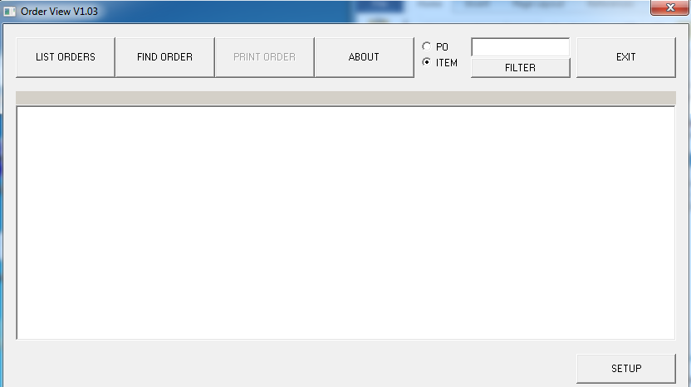

- SETUP: Select the SETUP button in the lower right corner to:
  - Select a Print Size when using the PRINT ORDER functionality (printers will vary and you may have to adjust the print size here).
  - Set how long you want previously transmitted order files (csv) to remain on your PC (Delete Old Orders). Any order files greater than this value will be deleted from your computer and will no longer be viewable. The default is 20 days.

- LIST ORDERS: Select List Orders to view all .csv files on your PC.
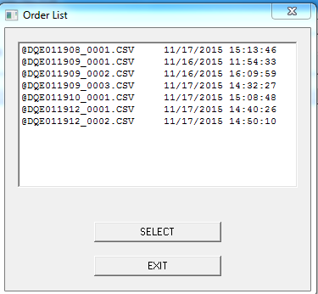

- Click on the file you want to view and ‘SELECT’. In this example, the contents of @DQE011908_0001.csv is displayed in the Order View screen. You cannot edit a .csv file.

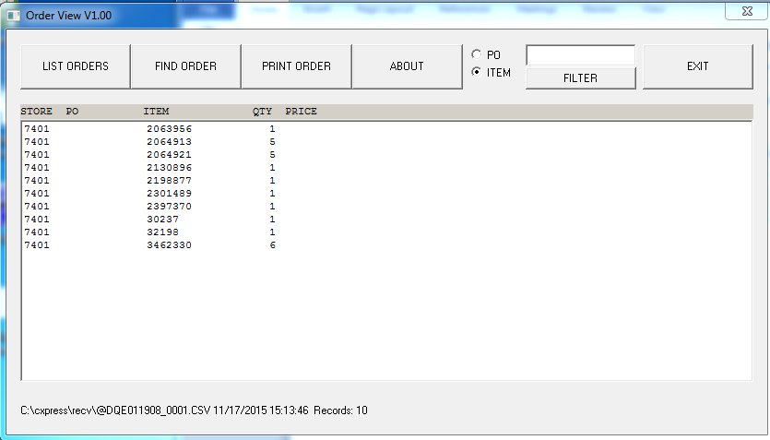

- FIND ORDER: If you know the name of the order file you want to view, select FIND ORDER. It will display a folder called recv which contains your order files. Double click on a file and the contents are displayed in the Order View screen.
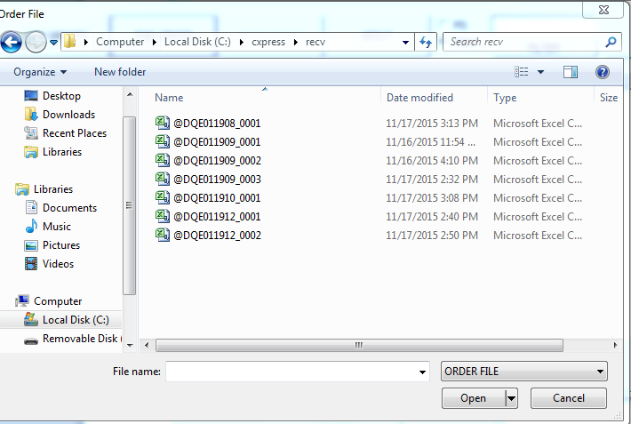

- PRINT ORDER: From the Order View screen, select PRINT ORDER to send a copy of the order lines in the selected .csv file to the printer connected to your PC. The print out will look just like what is displayed in the Order View screen. (You may have to adjust the print size by using the Print Size option in the SETUP menu.)

- ITEM FILTER: From the Order View screen, you can search for a particular item within the within the .csv file displayed. Enter the SKU or UPC in the Item field and select FILTER. Only the line SKU or UPC will display.
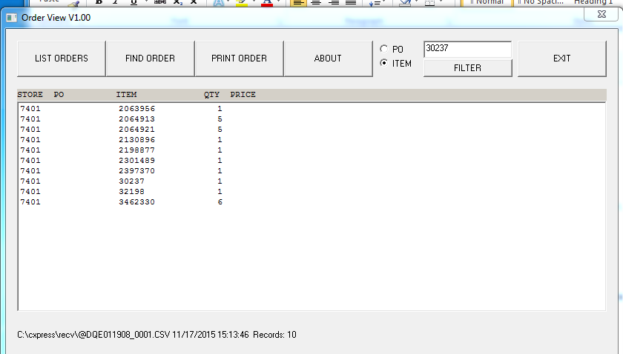

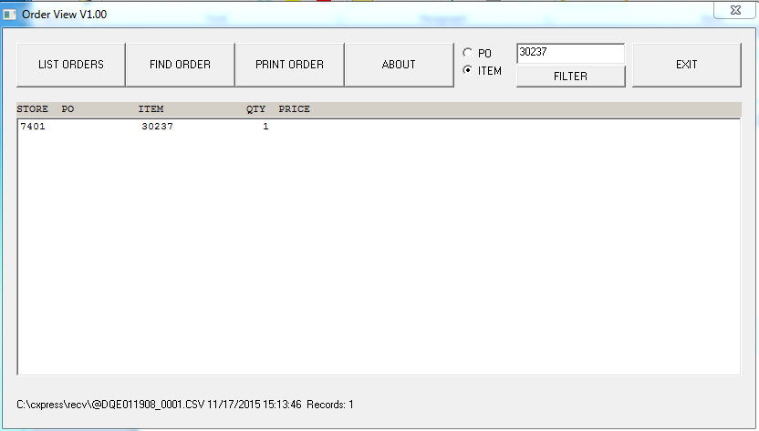
- PO FILTER: From the Order View screen, you can search for lines associated to a PO in the .csv file displayed. Enter the PO in the PO field and select FILTER. Only the lines with the PO will display.

- To EXIT the viewer, select EXIT.

WARNING/ ERROR MESSAGES (on the device):

CHECK DATA LENGTH | This message displays if a value entered into the ITEM field is not  - 5 digits (if the field has less than 5 digits, the application beeps and the message is not displayed)  - 7 digits  - 8 digits  - 12 digits  - 13 digits  - 14 digits  The maximum number of digits for an item is 14.
WARNING HIGH QTY XX  BLUE=ACCEPT  ESC = NO | This message displays if the order quantity entered is > the quantity entered as the MAX QTY in you System Setup. XX = the quantity entered.  Select Enter to accept the quantity  Select ESC to return to the item and adjust the quantity.
ITEM DELETE  ARE YOU SURE  BLUE=DELETE  ESC=CANCEL | This message displays when you are in REVIEW/EDIT mode and select the option to delete the order line.  Select Delete to delete the line and return to REVIEW/EDIT mode  Select Cancel to return to REVIEW/EDIT mode.
ITEM NOT FOUND  BLUE=CONTINUE | This message displays when you are in REVIEW/EDIT mode and search for a SKU or UPC that is not found within the partition.  Select Continue to return to REVIEW/EDIT mode.
NO DATA FILES EXIST  BLUE=CONTINUE | This message displays if  - The REVIEW / EDIT function is selected from the Main Menu and there are no partitions with pending orders, the NO DATA FILES EXIST message is displayed.  - The ERASE PARTITIONS function is selected from the Main Menu and there are no partitions with any order lines.  Continue brings you back to the Main Menu
NO ORDER TO SEND  BLUE=CONTINUE | If the SEND PARTITIONS function is selected and there are no partitions with pending orders, the NO ORDER TO SEND message is displayed.  Continue brings you back to the Main Menu
NO ITEMS RECORDED  CANCEL ORDER  BLUE=YES  ESC=NO | This message displays if a new partition is selected to enter order lines, but you escape before entering any order lines.  Selecting Yes brings you back to the Main Menu.  Selecting ESC brings you to the item entry screen.
12345-1  NOT SENT  ERASE ANYWAY  BLUE=YES  ESC=NO | This message displays if a partition is selected (ex. 12345-1) for deletion and it has not been transmitted.  Select YES to delete.  Select NO to keep the partition
OLD SENT  ORDER EXISTS  MUST ERASE  BLUE=CONTINUE | This message displays if a sent partition (name is proceeded by an ‘S’) is selected from the Order List within Item Entry. Sent partitions cannot be edited and must be manually erased from your device.  Select Enter to return to the Order List.
12345 – 1  ALREADY SENT  REVIEW ONLY  BLUE=REVIEW  ESC=CANCEL | This message displays if a sent partition (name is proceeded by an ‘S’) is selected from the Review List within the Review/Edit function. The sent partition is displayed at the top of the screen (example 12345-1).  Select Enter to review the contents of the sent partition.  Select ESC to return to the Review List.
DELETE DATA  ARE YOU SURE?  BLUE=YES  ESC=NO | This message displays if sent partition(s) (name is proceeded by an ‘S’) are tagged from the Delete List within the Erase Partitions function and you select ENTER.  Select Enter to delete the partition.  Select ESC to return to the Delete List
12345-1  NOT SENT  ERASE ANYWAY?  BLUE=YES  ESC=NO | This message displays if unsent partitions(s) are tagged from the Delete List within the Erase Partitions function and you select ENTER.  Select Enter to delete the partition.  Select ESC to return to the Delete List.
12345-1  ORD ALREADY SENT  CANNOT BE RESENT | This message displays if a sent partition (proceeded by an ‘S’) is selected from the Send List within the Send Partitions function. You cannot resend a successfully sent partition.
Ord_send  COMM ERR  RC=XXX  BLUE=RETRY  ESC=CANCEL | Communication Errors. Values for XXX may be:  2 = Potential issues are:  - Issue with the SFTP server (try again and if still receiving this return code, call the Customer Care Center)  - Make sure the Service Port option in SETUP is set to 10022  27 = Issue with the FTP server (try again and if still receiving this return code, call the Customer Care Center)  -002 = Make sure you keep the device in the cradle until the transmission has completed  -999 = Read timeout error. When sending an order:  - Make sure the device is in the cradle before sending any partitions.  (in this case, you will see multiple LineB….lines on the device)  - Make sure the CipherExpress software is running on the PC (double click the shortcut on the desktop to run)  - Make sure the cradle is connected to the PC  - Make sure the PC is connected to the Internet
PKG NOT FOUND | This message is usually received when something on you PC is preventing you from connecting to the server. If you have never connected to the server, contact the Customer Care Center to troubleshoot the issue.  If you have connected to the server and are trying to download a new version of the software, this message is received when the software is not available on the server. Contact the Customer Care Center.
COMM OPEN FAILED PORT = # | 1. Check if the CipherExpress software is already open on your PC. Close both sessions and open just one session.  2. If #1 does not work, reboot the PC and start the CipherLab session.  3. If neither #1 nor #2 work, reinstall the CipherExpress software from the retailer download website www.dcs-ace.com/retail.asp.

QUESTIONS? | If you have any questions about your device or order, call the Customer Care Center.

APPENDIX I

IMPORTANT NOTICES

For USA
This equipment has been tested and found to comply with the limits for a Class B digital device, pursuant to Part 15 of the FCC Rules. These limits are designed to provide reasonable protection against harmful interference in a residential installation. This equipment generates, uses and can radiate radio frequency energy and, if not installed and used in accordance with the instructions, may cause harmful interference to radio communications. However, there is no guarantee that interference will not occur in a particular installation. If this equipment does cause harmful interference to radio or television reception, which can be determined by turning the equipment off and on, the user is encouraged to try to correct the interference by one or more of the following measures:
- Reorient or relocate the receiving antenna.
- Increase the separation between the equipment and receiver.
- Connect the equipment into an outlet on a circuit different from that to which the receiver is connected.
- Consult the dealer or an experienced radio/TV technician for help.
This device complies with Part 15 of the FCC Rules. Operation is subject to the following two conditions: (1) This device may not cause harmful interference, and (2) this device must accept any interference received, including interference that may cause undesired operation.

For Canada
This digital apparatus does not exceed the Class B limits for radio noise emissions from digital apparatus as set out in the interference-causing equipment standard entitled "Digital Apparatus," ICES-003 of Industry Canada.
This device complies with Part 15 of the FCC Rules. Operation is subject to the following two conditions: (1) This device may not cause harmful interference, and (2) this device must accept any interference received, including interference that may cause undesired operation.
Cet appareil numerique respecte les limites de bruits radioelectriques applicables aux appareils numeriques de Classe B prescrites dans la norme sur le material brouilleur: "Appareils Numeriques," NMB-003 edictee par l'Industrie.

For Hand-held Product with RF Functions
This equipment complies with FCC radiation exposure limits set forth for an uncontrolled environment. This equipment should be installed and operated with minimum distance 20 cm between the radiator & your body. It only operated in hand-held used.

If you only transfer data to the host wirelessly, please keep the minimum distance 20 cm between machine & your body.

For Product with Laser

CAUTION
This laser component emits FDA / IEC Class 2 laser light at the exit port. Do not stare into beam.

Safety Precautions
RISK OF EXPLOSION IF BATTERY IS REPLACED BY AN INCORRECT TYPE. DISPOSE OF USED BATTERIES ACCORDING TO THE INSTRUCTIONS.The use of any batteries or charging devices, which are not originally sold or manufactured by CipherLab, will void your warranty and may cause damage to human body or the product itself.DO NOT disassemble, incinerate or short circuit the battery.DO NOT expose the scanner or the battery to any flammable sources.For green-environment issue, it's important that batteries should be recycled in a proper way. Under no circumstances, internal components are self-serviceable.The charging and communication cradle uses an AC power adaptor. A socket outlet shall be installed near the equipment and shall be easily accessible. Make sure there is stable power supply for the mobile computer or its peripherals to operate properly.

Care & Maintenance
- This mobile computer is intended for enterprise logistics use. The mobile computer is rated IP 52, however, it may do damage to the mobile computer when being exposed to extreme temperatures or soaked wet.
- When the body of the mobile computer gets dirty, use a clean and wet cloth to wipe off the dust. DO NOT use/mix any bleach or cleaner. Always keep the LCD dry.
- For a liquid crystal display (LCD), use a clean, non-abrasive, lint-free cloth to wipe dust off the screen. DO NOT use any pointed or sharp object to move against the surface.
- If you want to put away the mobile computer for a period of time, download the collected data to a host computer, and then take out the battery pack. Store the mobile computer and battery pack separately.
- When the mobile computer resumes its work, the main and backup batteries will take a certain time to become fully charged.
- Keep the mobile computer away from any magnets and magnetic fields to prevent the laser engine from malfunctioning.
- If you shall find the mobile computer malfunctioning, write down the specific scenario and consult your local sales representative.

